1.

a.

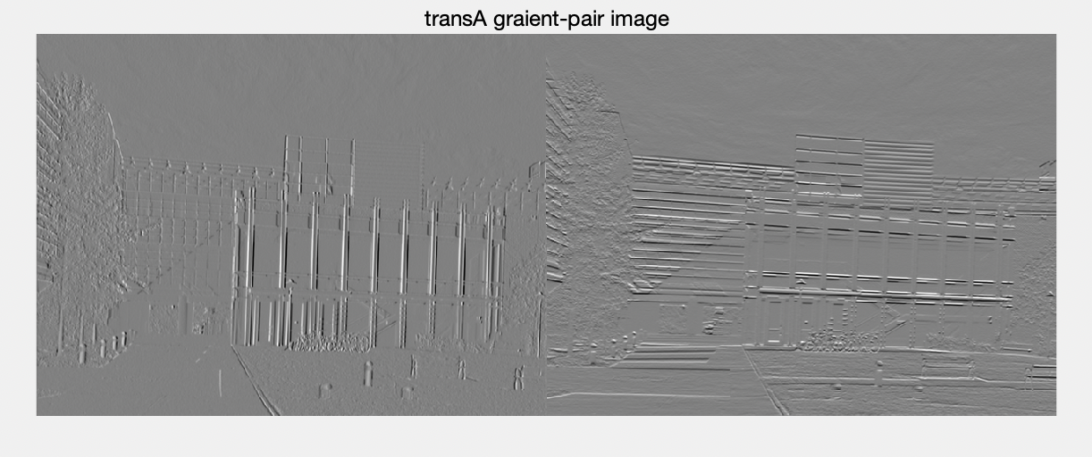

ps5-1-a-1.png

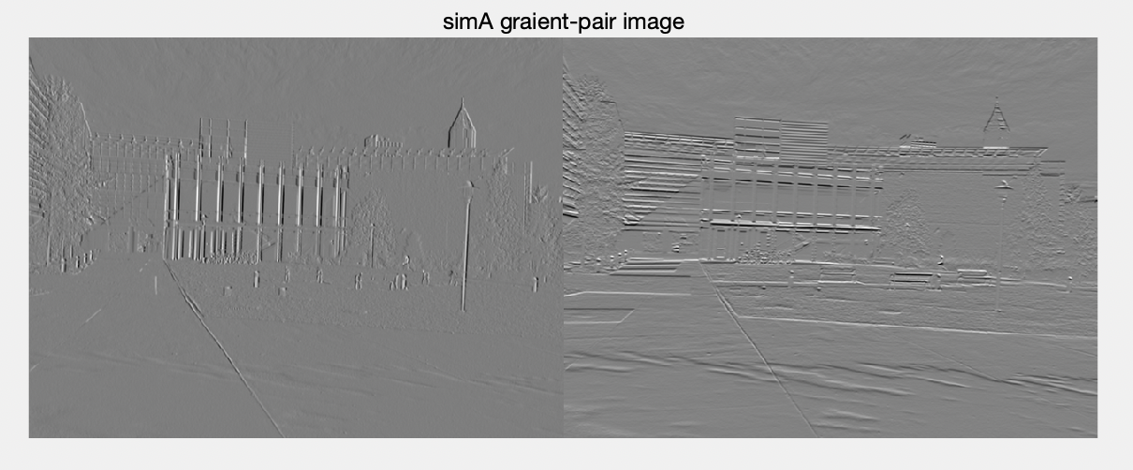

ps5-1-a-2.png

b.

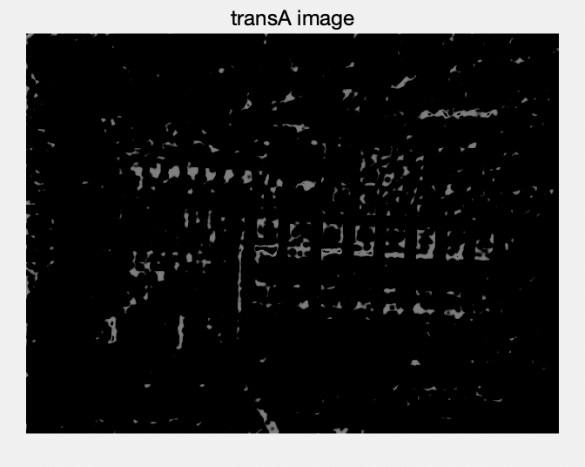

ps5-1-b-1.png

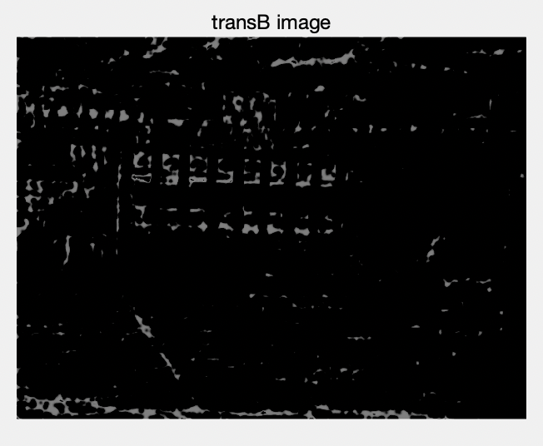

ps5-1-b-2.png

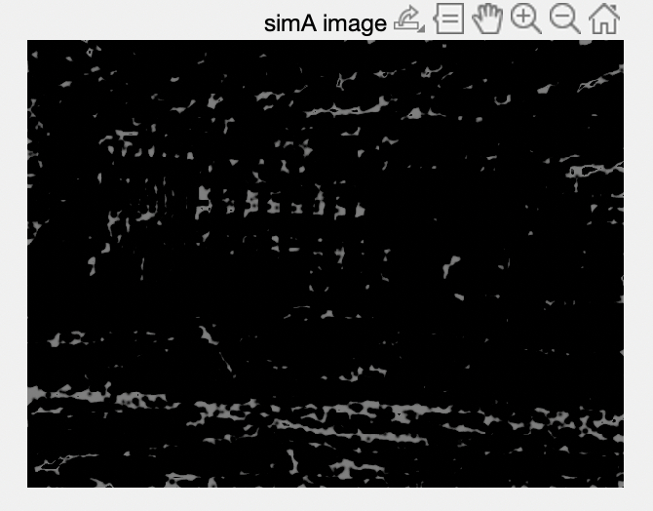

ps5-1-b-3.png

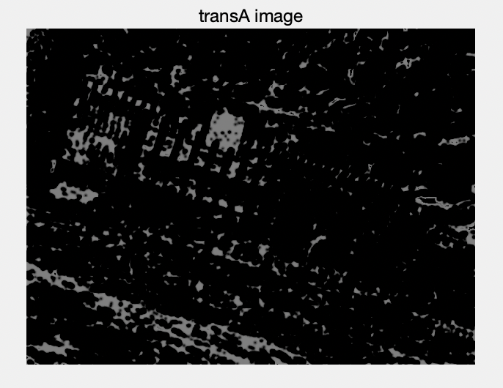

ps5-1-c-png

c.

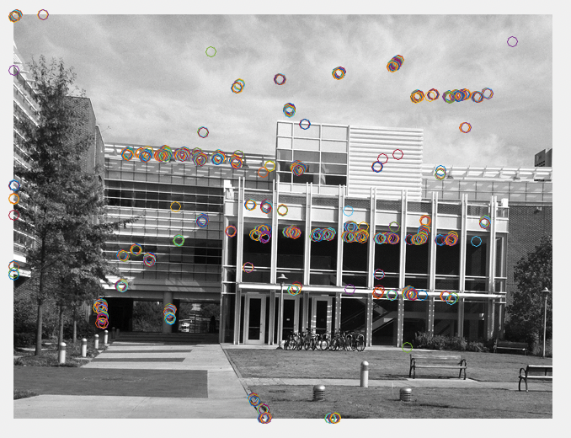

ps5-1-c-1.png

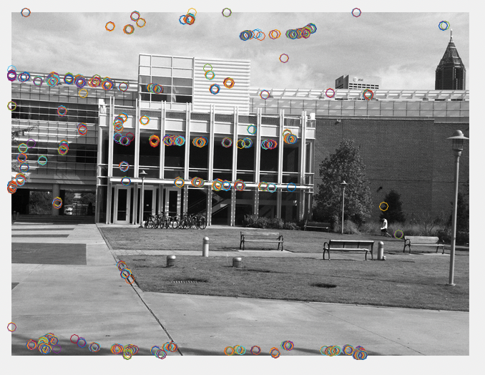

ps5-1-c-2.png

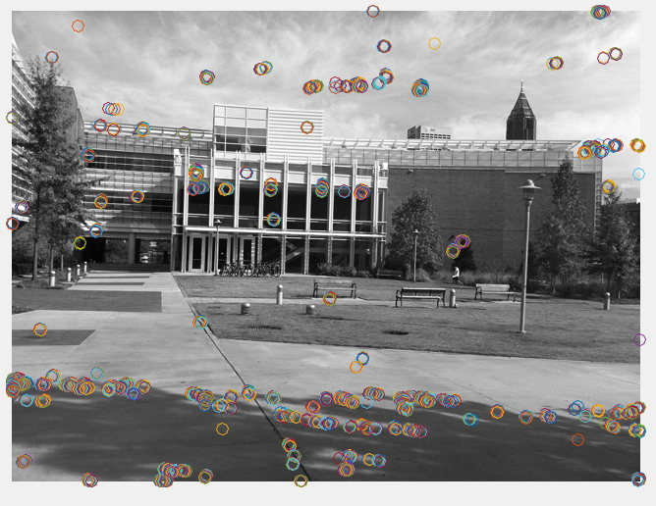

ps5-1-c-3.png

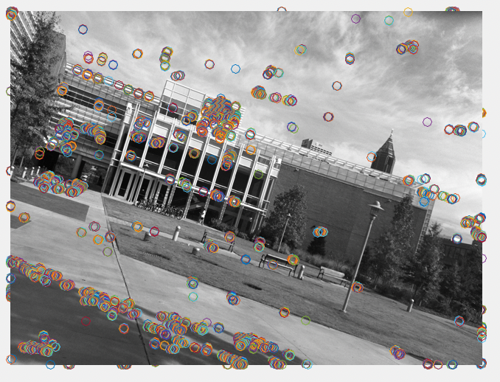

ps5-1-c-4.png

For the image simB I found that comparing the corner point with the other three pictures, with the same parameters such as threshold, it has more corners than the others, probably because this picture is oblique, and his x and y gradient image is different from other pictures, which leads to the identification of a lot of extra corner point.

2.

a.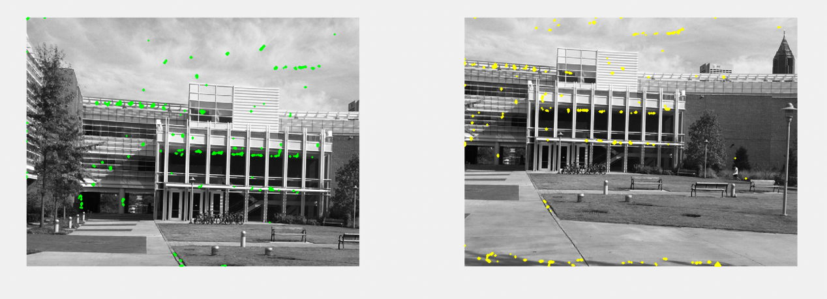

ps5-2-a-1.png

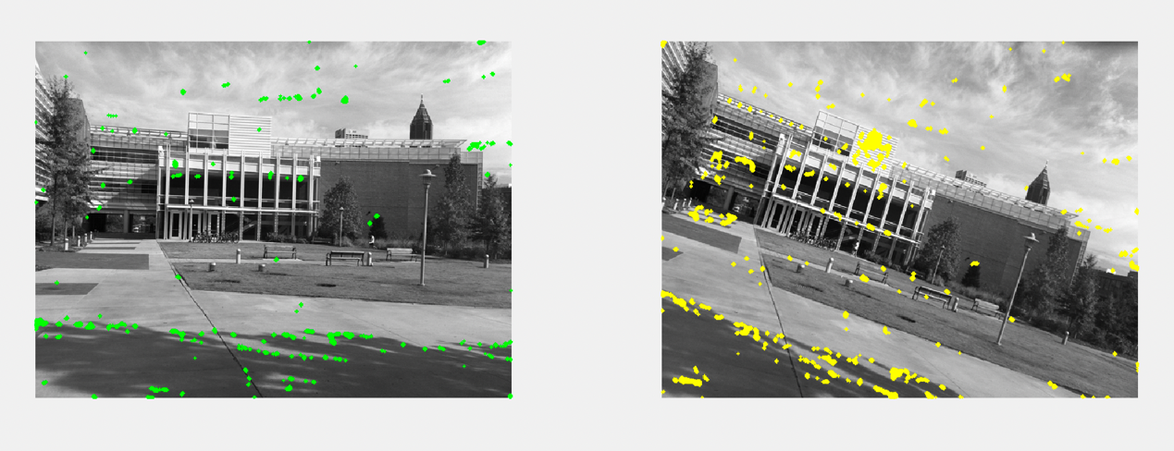

ps5-2-a-2.png

b.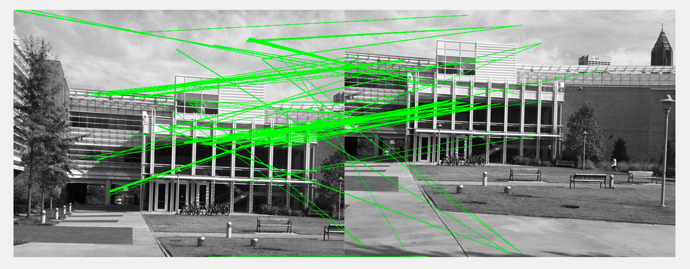

ps5-2-b-1.png

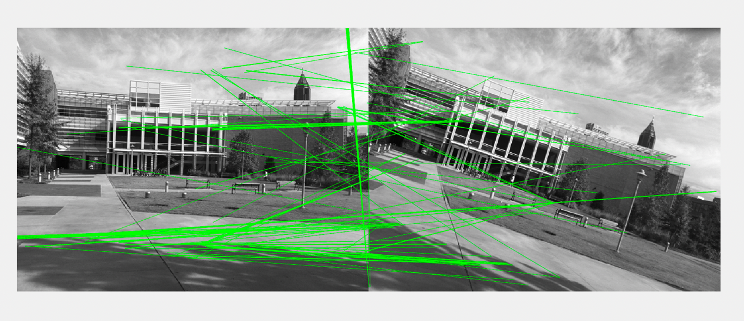

ps5-2-b-2.png

c

a. 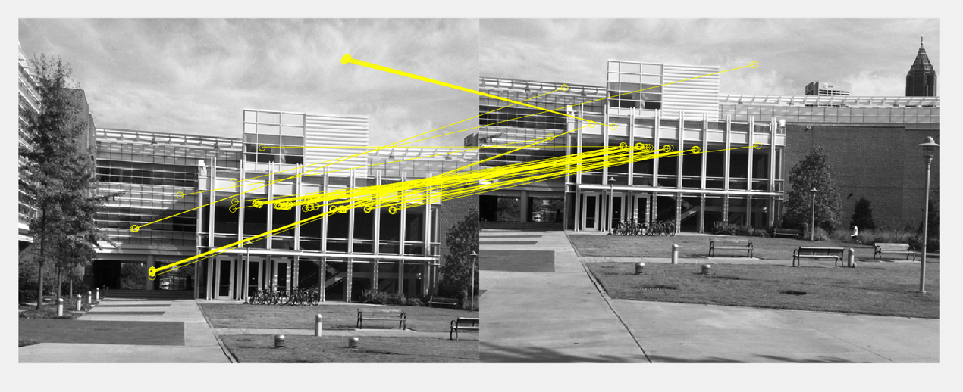

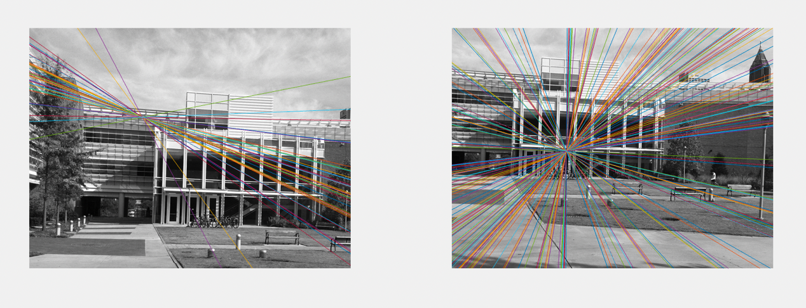

ps5-3-a-1.png

125/136 = 91.9%

b.

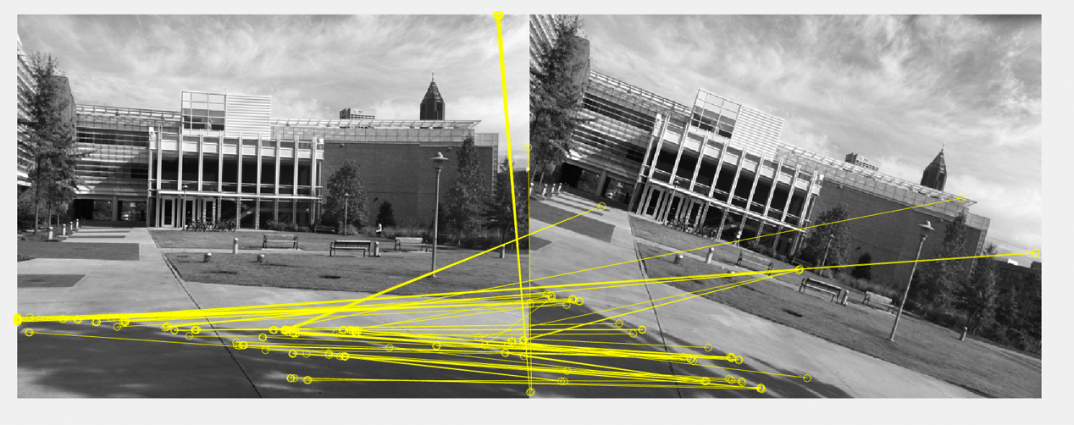

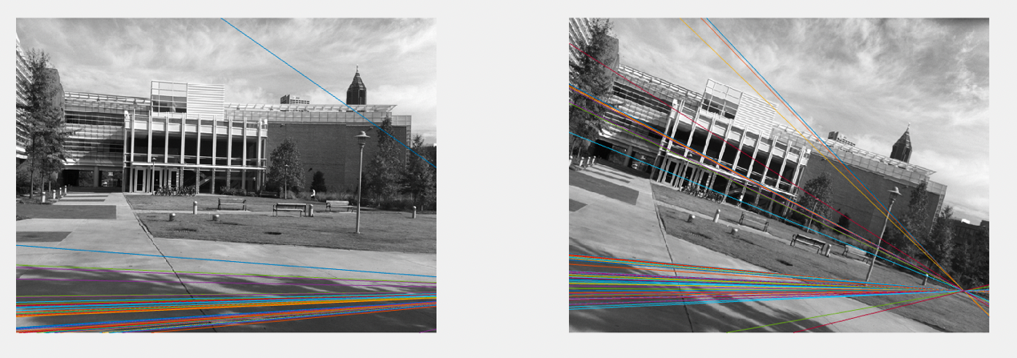

ps5-3-b-1.png

127/187 = 67.9%